Computer-Aided Design and Optimization of a Microwave Impedance-Matching Network and Frequency-Selective Filter
Aim:
To design and simulate a microwave impedance-matching network and frequency-selective filter using simulation software and analyze their performance.
Procedure:
- Open MATLAB or suitable microwave simulation software.
- Design an impedance-matching network by specifying the source impedance, load impedance, and operating frequency.
- Design a frequency-selective filter with the required cutoff frequency and bandwidth.
- Simulate both circuits and plot their frequency responses and S-parameters.
- Optimize the circuit parameters to minimize reflection and improve impedance matching and filter performance.
Code:
clc;
clear;
close all;
%% 1. INPUT PARAMETERS
f0 = 10e9; % Design frequency = 10 GHz
Z0 = 50; % Reference impedance = 50 ohms
ZL = 75 + 1j*25; % Load impedance = 75 + j25 ohms
fc = 10e9; % Filter cutoff frequency = 10 GHz
fstart = 8e9; % Start frequency = 8 GHz
fstop = 12e9; % Stop frequency = 12 GHz
f = linspace(fstart, fstop, 1001);
w0 = 2*pi*f0;
w = 2*pi*f;
%% 2. INITIAL LOAD ANALYSIS
GammaL = (ZL - Z0)/(ZL + Z0);VSWRL = (1 + abs(GammaL))/(1 - abs(GammaL));
fprintf('MICROWAVE IMPEDANCE MATCHING NETWORK\n');
fprintf('-----------------------------------\n');
fprintf('Design frequency = %.2f GHz\n', f0/1e9);
fprintf('Reference impedance = %.2f ohms\n', Z0);
fprintf('Load impedance = %.2f + j%.2f ohms\n', ...
real(ZL), imag(ZL));
fprintf('Initial reflection coefficient = %.4f %+.4fj\n', ...
real(GammaL), imag(GammaL));
fprintf('Initial |Gamma| = %.4f\n', abs(GammaL));
fprintf('Initial VSWR = %.4f\n\n', VSWRL);
%% 3. IMPEDANCE-MATCHING NETWORK OPTIMIZATION
% Topology: series reactance followed by shunt susceptance
% Optimize Xs (ohms) and Bs (siemens) at the design frequency.
objective = @(x) matching_error(x, ZL, Z0);
x0 = [40, 0.005];
options = optimset('Display','off', ...
'MaxIter',5000, ...
'MaxFunEvals',10000, ...
'TolX',1e-12, ...
'TolFun',1e-14);
xopt = fminsearch(objective, x0, options);
Xs = xopt(1); % Series reactance at f0
Bs = xopt(2); % Shunt susceptance at f0
% Convert reactance into a physical series inductor or capacitor
if Xs > 0
Ls = Xs/w0;
Cs = NaN;
seriesType = 'Inductor';
elseif Xs < 0
Cs = -1/(w0*Xs);
Ls = NaN;
seriesType = 'Capacitor';
else
Ls = NaN;
Cs = NaN;
seriesType = 'None';
end
% Convert susceptance into a physical shunt capacitor or inductor
if Bs > 0
Cp = Bs/w0;
Lp = NaN;
shuntType = 'Capacitor';
elseif Bs < 0
Lp = -1/(w0*Bs);
Cp = NaN;
shuntType = 'Inductor';
else
Cp = NaN;
Lp = NaN;
shuntType = 'None';
end
%% 4. FREQUENCY SWEEP OF MATCHING NETWORK
% Frequency-dependent series reactance
if Xs > 0
Xseries = w*Ls;
elseif Xs < 0
Xseries = -1./(w*Cs);
else
Xseries = zeros(size(f));
end
% Frequency-dependent shunt susceptance
if Bs > 0
Bshunt = w*Cp;
elseif Bs < 0
Bshunt = -1./(w*Lp);
else
Bshunt = zeros(size(f));
end
Zseries = ZL + 1j*Xseries;
Yin = 1./Zseries + 1j*Bshunt;
Zin = 1./Yin;
GammaIn = (Zin - Z0)./(Zin + Z0);
S11_dB = 20*log10(max(abs(GammaIn),1e-12));
VSWR = (1 + abs(GammaIn))./(1 - abs(GammaIn));
% Exact design-frequency result
Zseries0 = ZL + 1j*Xs;
Zin0 = 1/(1/Zseries0 + 1j*Bs);
Gamma0 = (Zin0 - Z0)/(Zin0 + Z0);
VSWR0 = (1 + abs(Gamma0))/(1 - abs(Gamma0));
fprintf('OPTIMIZED MATCHING NETWORK\n');
fprintf('--------------------------\n');
fprintf('Series element type: %s\n', seriesType);
fprintf('Series reactance = %.4f ohms\n', Xs);
if isfinite(Ls)
fprintf('Series inductance = %.4f pH\n', Ls*1e12);
end
if isfinite(Cs)
fprintf('Series capacitance = %.4f fF\n', Cs*1e15);
end
fprintf('Shunt element type: %s\n', shuntType);
fprintf('Shunt susceptance = %.6f S\n', Bs);
if isfinite(Cp)
fprintf('Shunt capacitance = %.4f fF\n', Cp*1e15);
end
if isfinite(Lp)
fprintf('Shunt inductance = %.4f pH\n', Lp*1e12);
end
fprintf('\nMatched input impedance at 10 GHz:\n');
fprintf('Zin = %.4f %+.4fj ohms\n', real(Zin0), imag(Zin0));
fprintf('|Gamma| = %.6f\n', abs(Gamma0));
fprintf('Return loss = %.4f dB\n', -20*log10(max(abs(Gamma0),1e-12)));
fprintf('VSWR = %.4f\n\n', VSWR0);
%% 5. THIRD-ORDER BUTTERWORTH LOW-PASS FILTER
% Ideal normalized Butterworth magnitude response
N = 3;
Hmag = 1./sqrt(1 + (f/fc).^(2*N));
H_dB = 20*log10(max(Hmag,1e-12));
fprintf('FREQUENCY-SELECTIVE FILTER\n');
fprintf('--------------------------\n');
fprintf('Filter type = Third-order Butterworth low-pass\n');
fprintf('Cutoff frequency = %.2f GHz\n', fc/1e9);
fprintf('Sweep range = %.2f to %.2f GHz\n', ...
fstart/1e9, fstop/1e9);
fprintf('Ideal attenuation at cutoff = %.2f dB\n', ...
20*log10(1/sqrt(2)));
%% 6. PLOT INPUT REFLECTION COEFFICIENT
figure;
plot(f/1e9, abs(GammaIn), 'b', 'LineWidth', 2);
grid on;
xlabel('Frequency (GHz)');
ylabel('|S_{11}|');
title('Reflection Coefficient of Matching Network');
xline(f0/1e9, '--r', 'Design Frequency');
%% 7. PLOT RETURN LOSS
figure;
plot(f/1e9, S11_dB, 'r', 'LineWidth', 2);
grid on;
xlabel('Frequency (GHz)');
ylabel('S_{11} (dB)');
title('Return Loss of Matching Network');
xline(f0/1e9, '--k', '10 GHz');
%% 8. PLOT VSWR
figure;
plot(f/1e9, VSWR, 'm', 'LineWidth', 2);
grid on;
xlabel('Frequency (GHz)');
ylabel('VSWR');
title('VSWR versus Frequency');
xline(f0/1e9, '--k', 'Design Frequency');
%% 9. PLOT FILTER FREQUENCY RESPONSE
figure;
plot(f/1e9, H_dB, 'LineWidth', 2);
grid on;
xlabel('Frequency (GHz)');
ylabel('Magnitude (dB)');
title('Third-Order Butterworth Low-Pass Filter Response');
xline(fc/1e9, '--r', 'Cutoff = 10 GHz');
yline(-3.0103, '--k', '-3 dB');
%% 10. PLOT INPUT IMPEDANCE
figure;
plot(f/1e9, real(Zin), 'b', 'LineWidth', 2);
hold on;
plot(f/1e9, imag(Zin), 'r--', 'LineWidth', 2);
grid on;
xlabel('Frequency (GHz)');
ylabel('Impedance (ohms)');
title('Input Impedance of Matching Network');
legend('Real(Zin)', 'Imag(Zin)', 'Location', 'best');
xline(f0/1e9, ':k', '10 GHz');
%% LOCAL OBJECTIVE FUNCTION
function err = matching_error(x, ZL, Z0)
Xs = x(1);
Bs = x(2);
Zseries = ZL + 1j*Xs;
Yin = 1/Zseries + 1j*Bs;
Zin = 1/Yin;
Gamma = (Zin - Z0)/(Zin + Z0);
err = abs(Gamma)^2;
if ~isfinite(err)
err = 1e10;
end
end
Output:
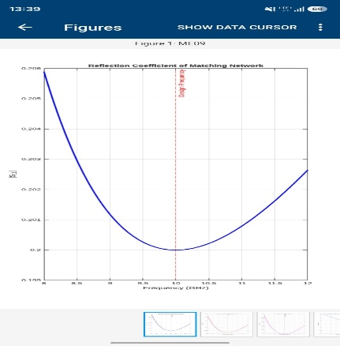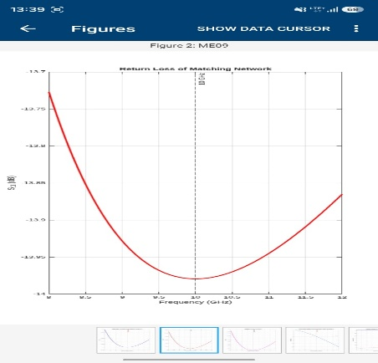

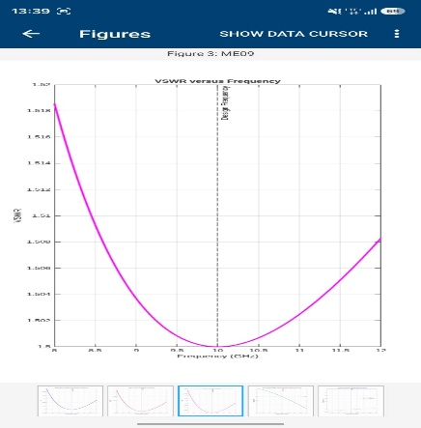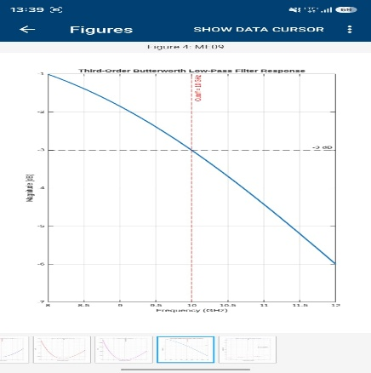

Result:
The microwave impedance-matching network and frequency-selective filter were designed and simulated successfully. Their performance was analyzed using S-parameters and frequency-response plots, and suitable parameters were optimized to improve impedance matching and frequency selectivity.

